Create an agent from a template
In this exercise, you will create an agent by using a template and then test the agent.
Task 1.1 – Create an agent from the Safe Travels template
- Navigate to the Copilot Studio home page https://copilotstudio.microsoft.com/.
- Make sure you are in the Copilot Studio classic experience. If you are using the new Copilot Studio experience, select the ellipsis (…) next to your account in the lower-left corner, and then select Open classic experience before proceeding.
- If the Share feedback before opening the previous experience? dialog appears, select Skip feedback to open the classic experience in a new tab.
- If the Welcome to Microsoft Copilot Studio dialog appears, select Get Started and skip any welcome messages.
- At the top of the page, verify that you are working in the environment you want to use for this exercise.
- Select Agents in the left-hand navigation.
- Under Start with an agent template section, select the Safe Travels template.
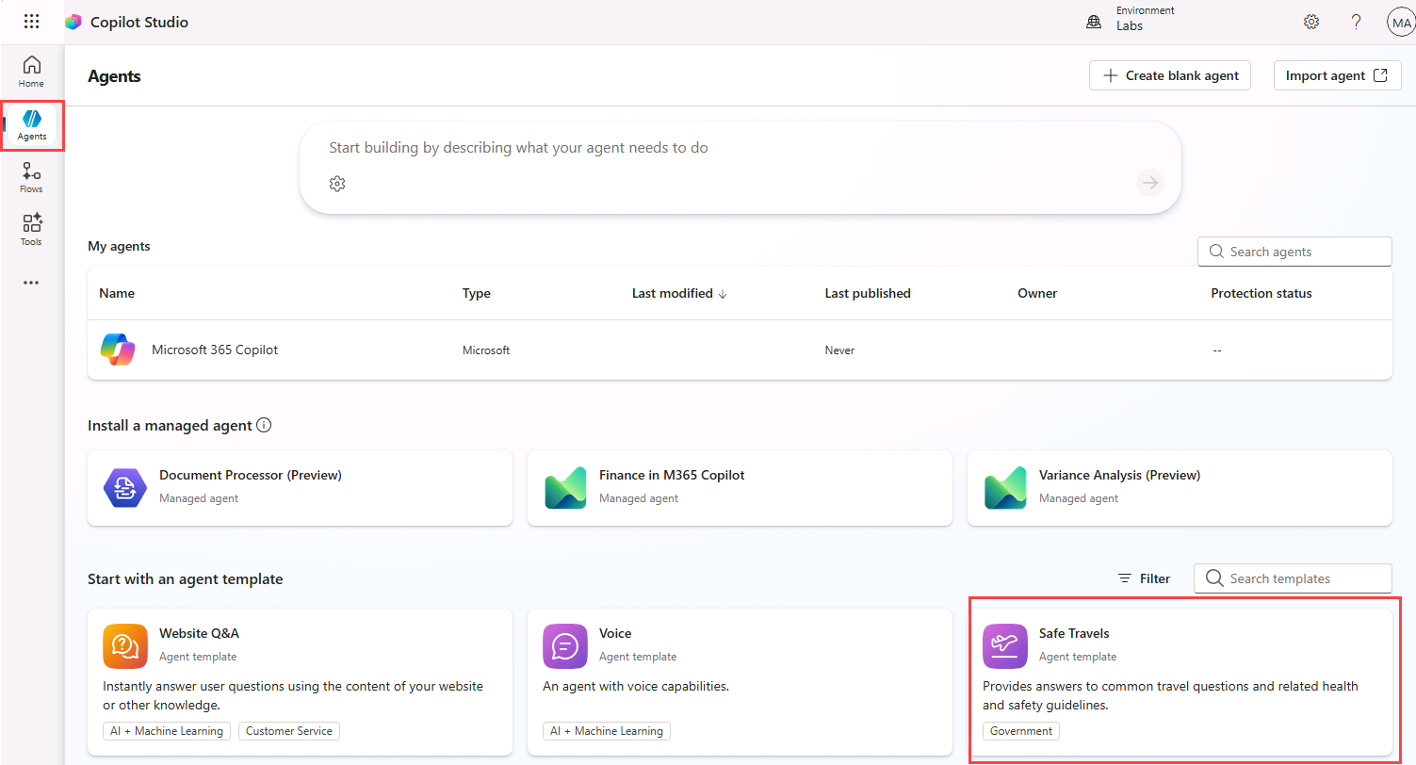
- In the upper-right of the page, select the ellipsis (…) and select Edit advanced settings.
- Validate that the selected Solution is Lab Exercises, the Schema name prefix is fab, and then select Cancel.
- In the upper-right of the page, select Create.
- In the Overview tab, review the name, description, and agent instructions.
- Select the Knowledge tab and review the public website that has been added as a knowledge source.
- In the upper-right of the page, select the Settings button.
- Note that Orchestration is set to No - Use classic orchestration, limiting responses to the content and behavior defined in your agent’s topics.
- In the upper-right of the Settings page, select X to close settings.
- Select the Topics tab and select the System filter.
- Select the Conversation Start topic. Review the contents of the Message node. Note that the contents of the message are displayed in the Test pane.
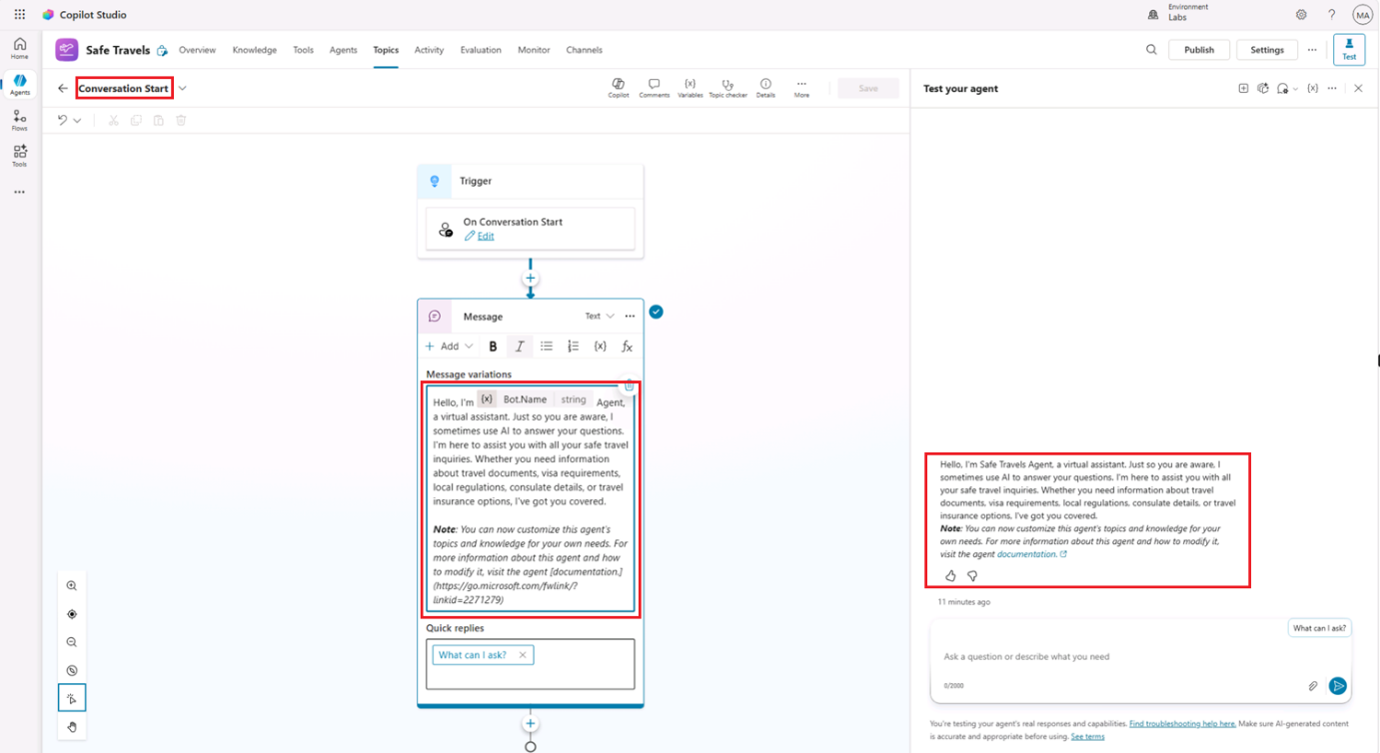
- In the drop-down in the upper-left of the page that is showing Conversation Start, select the custom What can I ask topic.
Task 1.2 – Test the agent
- If the Test pane is not visible, select the Test icon in the upper-right of the page.
- In the Test pane, select the ellipsis (…) next to the variables {x} icon, and toggle Track between topics to On.
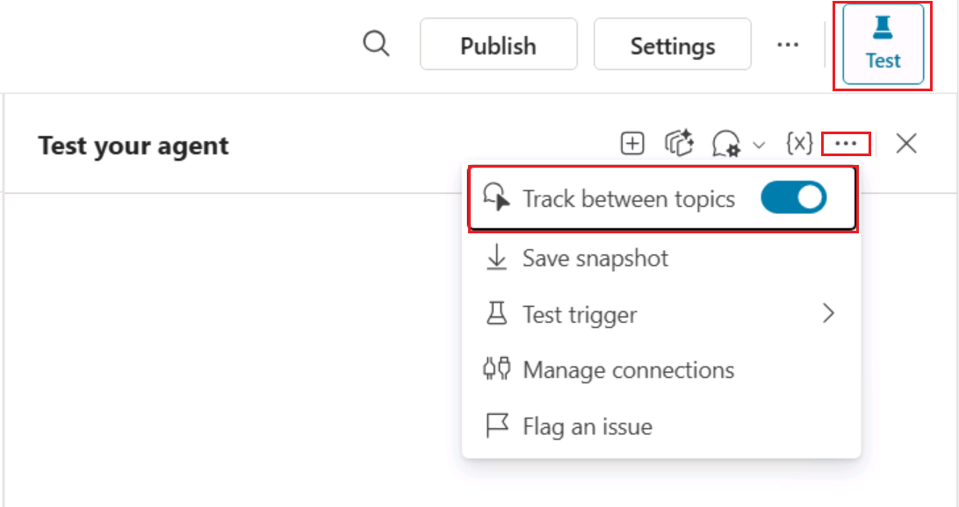
- Enter the following prompt:
code
Hello
The Greeting topic should be selected and the response is provided from the message node in the Greeting topic.
- At the top of the Test pane, select the Start new test session icon +.
- Enter the following prompt:
code
What can I ask?
The What Can I Ask topic should be triggered and present several prompt options to continue the conversation.
- Select the How do I get a passport? option.
The response should be generated using the configured knowledge source and may reference the Conversational boosting system topic.
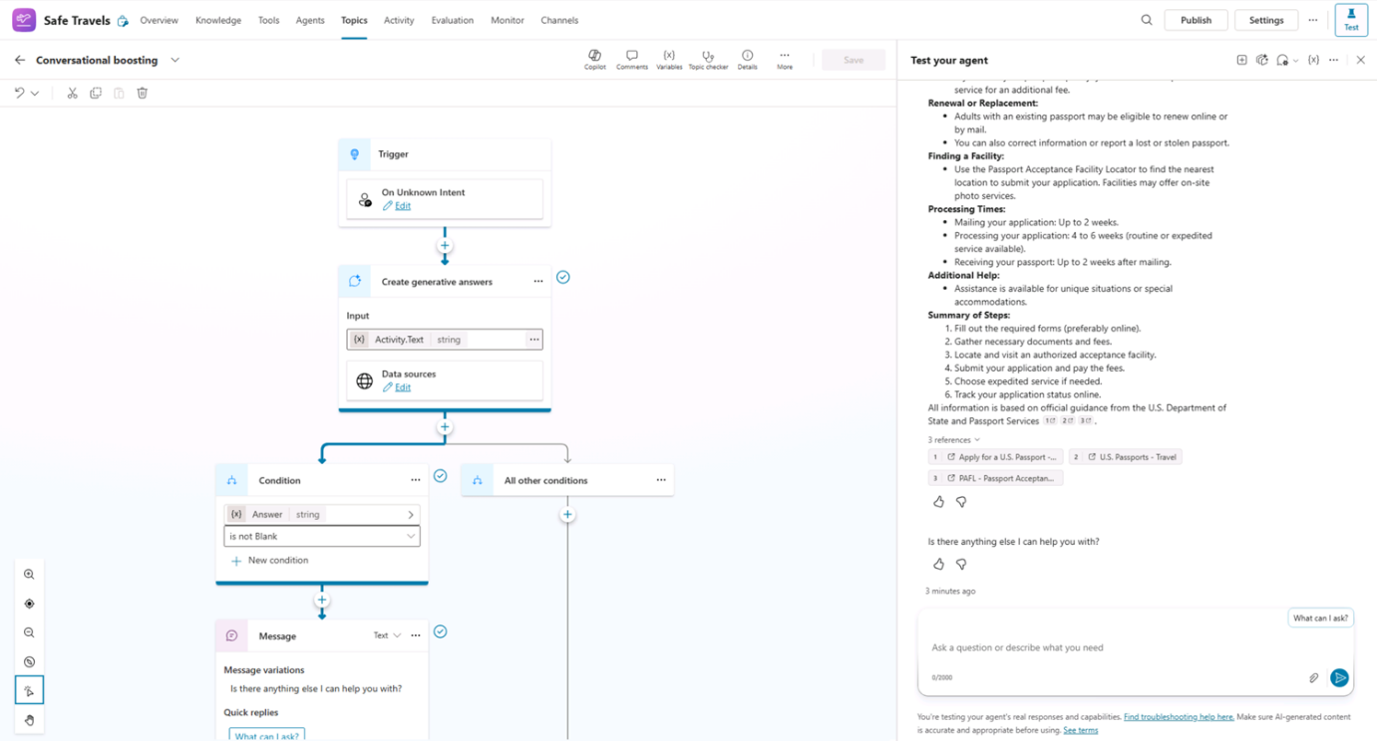
- Enter the following prompt:
code
What is Copilot Studio?
The Fallback topic should be selected, and agent should ask you to try rephrasing.
- Repeat the same prompt twice more. Depending on your environment and orchestration behavior, the agent may trigger the Fallback or Escalate system topics.
- Select Agents in the left-hand navigation. The Safe Travels agent should be listed.

